SET 17 – EMPLOYEE PERFORMANCE ANALYSIS
Aim
To analyze employee performance using a line chart, bar chart, and table in R.
Algorithm
- Create the employee performance dataset.
- Store Employee ID, Department, Years of Service, and Performance Score.
- Create a line chart to visualize employee performance.
- Create a bar chart to show performance across departments.
- Display the employee data in a table.
- Add suitable labels and titles.
R Program
library(ggplot2)

employee <- data.frame(
ID=c(1,2,3),
Department=c("Sales","HR","Marketing"),
Years=c(5,3,7),
Score=c(85,92,78)
)

ggplot(employee, aes(Years, Score, group=1)) +
geom_line() +
geom_point() +
labs(title="Employee Performance Trend",
x="Years of Service", y="Performance Score")

ggplot(employee, aes(Department, Score, fill=Department)) +
geom_bar(stat="identity") +
labs(title="Employee Performance by Department",
x="Department", y="Performance Score")

print(employee)
OUTPUT:
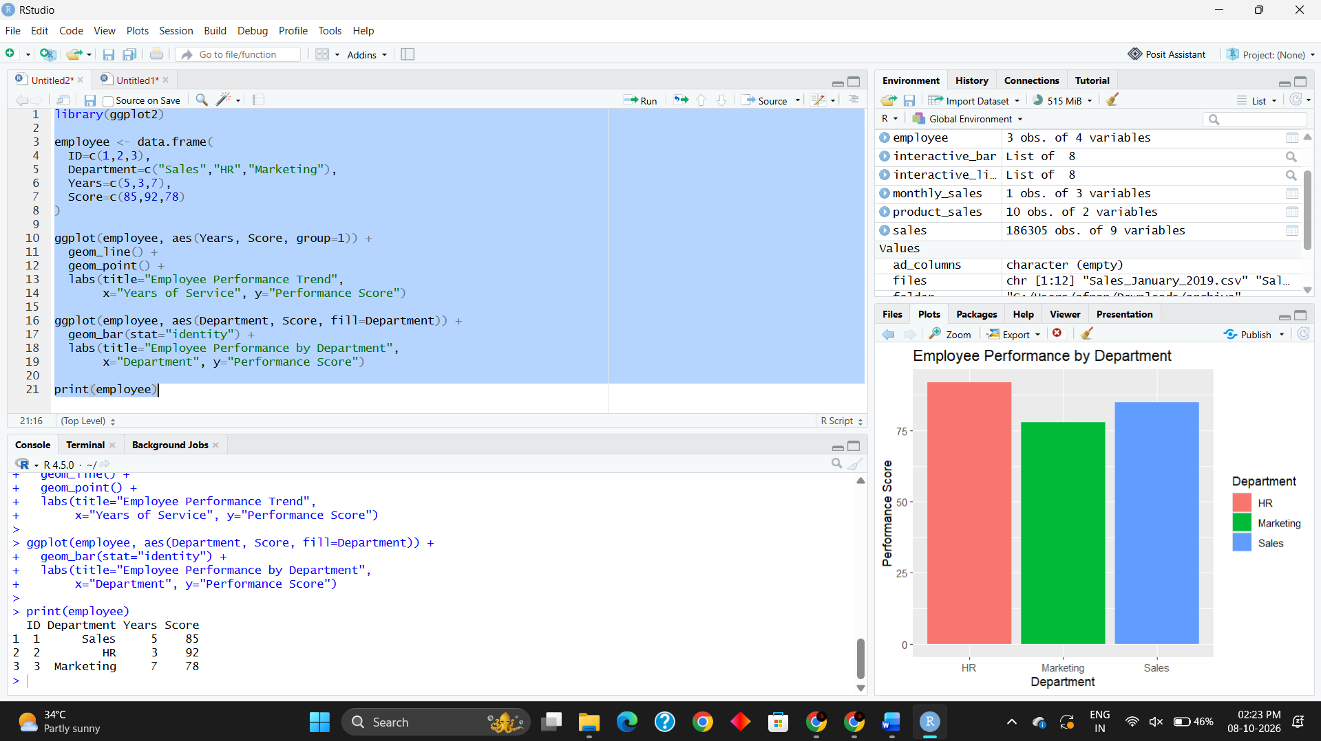
Result
The line chart successfully shows the employee performance trend based on years of service. The bar chart compares performance scores across departments, and the table displays the employee performance data.

